

**COMPUTER ENGINEERING**

**DS ODD SEM 2021-22/EXPERIMENT 5 NAME:- GAURAV AMARNANI (D7A, 67)**

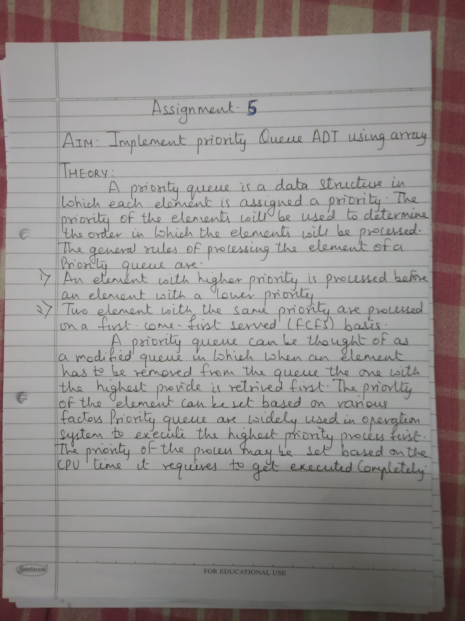

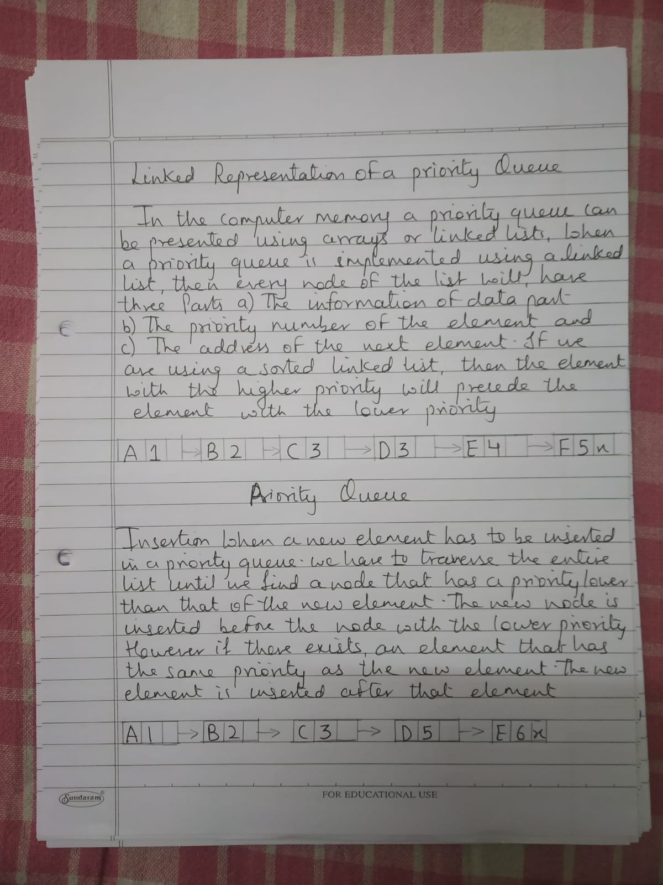

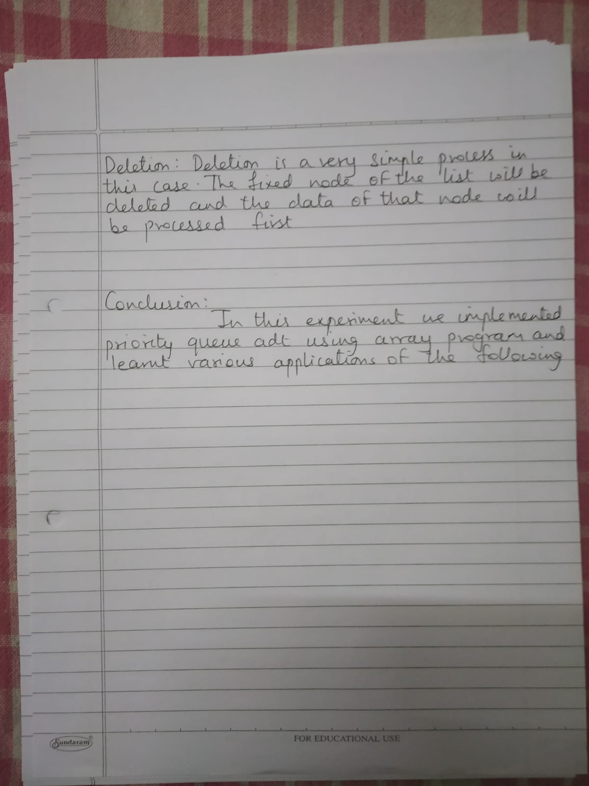

**PROGRAM:**

#include<stdio.h>

#define N 50

int Q[N],Pr[N];

int r = -1,f = -1;

void enqueue(int data,int p) {

int i;

if((f==0)&&(r==N-1))

else {

printf("Queue is full");

if(f==-1) {

f = r = 0;

Q[r] = data;

Pr[r] = p;

}

else if(r == N-1) {

for(i=f;i<=r;i++) {

Q[i-f] = Q[i];

Pr[i-f] = Pr[i];

r = r-f;

f = 0;

else

Q[i+1] = Q[i];

Pr[i+1] = Pr[i];

break;

Q[i+1] = data;

Pr[i+1] = p;

r++;

}

}

}

else {

Q[i+1] = Q[i];

Pr[i+1] = Pr[i];

}

}

void print() {

int i;

for(i=f;i<=r;i++) {

printf("\nElement = %d\tPriority = %d",Q[i],Pr[i]);

}

}

int dequeue() {

if(f == -1) {

}

else {

printf("Queue is Empty");

printf("deleted Element = %d\t Its Priority = %d",Q[f],Pr[f]);

if(f==r)

f = r = -1;

else

}

f++;

return(0);

}

void main() {

int opt,n,i,data,p;

printf("Enter Your Choice:-");

do{

printf("\n\n1 for Insert the Data in Queue\n2 for show the Data in Queue \n3 for Delete the data from the Queue\n0 for Exit");

scanf("%d",&opt);

switch(opt){

case 1:

printf("\nEnter the number of data");

scanf("%d",&n);

printf("\nEnter your data and Priority of data");

i=0;

while(i<n) {

scanf("%d %d",&data,&p);

enqueue(data,p);

i++;

}

break;

case 2:

print();

break;

case 3:

dequeue();

break;

case 0:

break;

default:

printf("\nIncorrect Choice");

}

} while(opt!=0);

}

OUTPUT:-

